# Lab - Linux Firewall

|  |
| --- |
| * This is an individual assignment and worth 5 points. * The due is tonight. * Submit the outcome file. Follow the naming convention. |

## Task 1

1. On Kali, create a rule that blocks ping requests to the Kali machine.
2. Go to the host machine and ping the Kali. Take a screenshot of the output on the host machine.
3. On Kali, display the rule you created. Take a screenshot of the output.

b.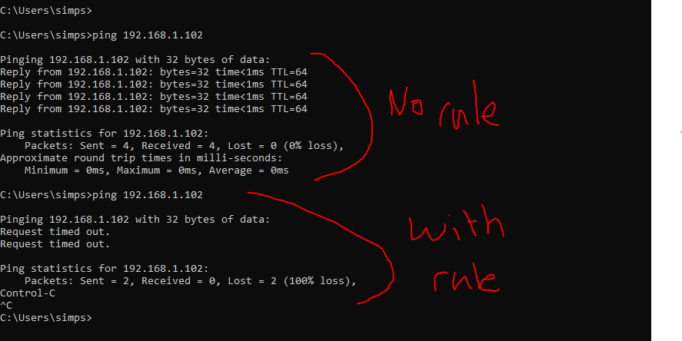C.

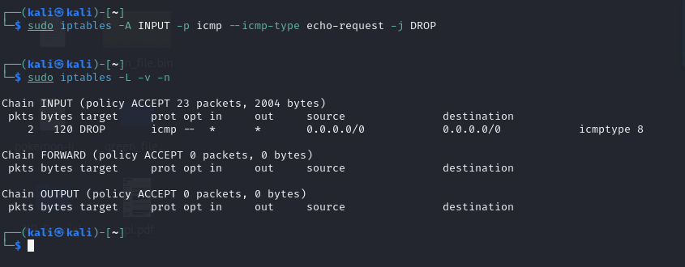

## Task 2

1. On Kali, launch Firefox and visit [hurmfamilydentistry.com](https://hurmfamilydentistry.com). Make sure the website is displayed properly.
2. Create a rule that blocks access to this site. On a separate tab of the browser, visit the site again and show in a screenshot that the site now is not accessible.
3. Display the rule you created. Take a screenshot of the output.

(Hint: watch the 2nd video in Tutorial 1).

b. 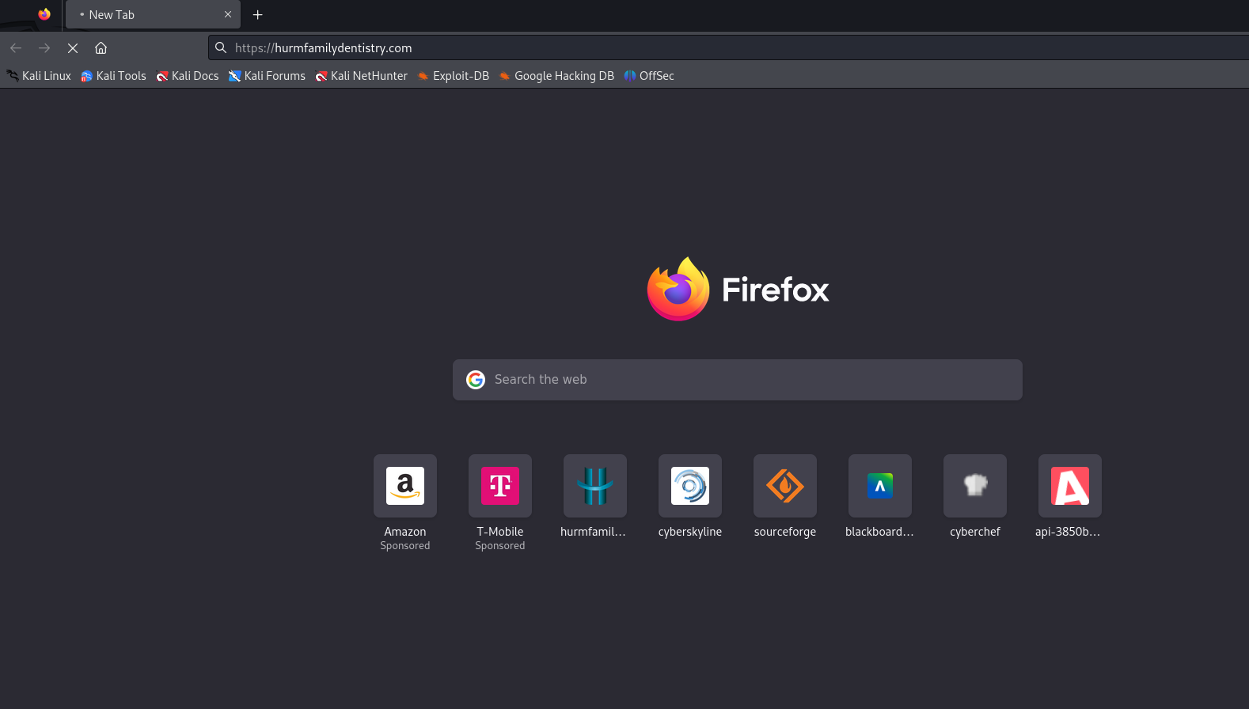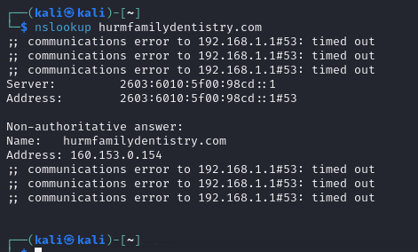

c.

